ZERO TRUST NETWORK ACCESS (ZTNA) WITH
ZSCLAER : REPLACE AND MODERNIZE LEGACY VPN ARCHITECTURES WITH A CLOUD-NATIVE

LIST OF TEAMMATES

COLLEGE CODE: bbrub
TEAM ID: SWTID-2026-9794

TEAM SIZE: 5
S. No | Name | College Id | Phone No
1. | GOKILA K | VET INSTITUTE OF ARTS AND SCIENCE COLLEGE | -
2. | KELAM S | VET INSTITUTE OF ARTS AND SCIENCE COLLEGE | -
3. | KRISHNAPRAGANESH G | VET INSTITUTE OF ARTS AND SCIENCE COLLEGE | -
4. | MEENA S | VET INSTITUTE OF ARTS AND SCIENCE COLLEGE | -
5. | SANJAY P V | VET INSTITUTE OF ARTS AND SCIENCE COLLEGE | -

Title of the Project: -
Implement Replace and modernize legacy VPN architectures with a cloud-native Zscaler Zero Trust solution to reduce attack surface and lateral movement.

Overview: -
Zero Trust Network Access (ZTNA) is a modern cybersecurity approach designed to secure access to applications by eliminating the traditional concept of a trusted internal network. Instead of automatically trusting users or devices inside a corporate network, the Zero Trust model operates on the principle of “never trust, always verify.” Every access request is continuously authenticated, authorized, and validated before granting access to applications or resources.
ZTNA ensures that users are connected only to specific applications they are authorized to use, rather than giving them access to the entire network. This significantly reduces the attack surface and helps prevent unauthorized access, data breaches, and lateral movement by attackers.
Zscaler is a leading cloud security platform that implements the Zero Trust architecture through its Zscaler Private Access (ZPA) solution. ZPA enables secure, direct connections between authenticated users and internal applications without exposing the applications to the public internet or requiring traditional VPN infrastructure. Unlike VPNs, which extend the network to the user, Zscaler connects the user directly to the application, ensuring a more secure and efficient access method.
With Zscaler’s ZTNA approach, users are authenticated through identity providers, and their devices are verified for security posture before access is granted. The platform continuously monitors user activity and enforces security policies in real time. This ensures that only legitimate users with compliant devices can access enterprise applications, whether they are hosted in on-premises data centers or cloud environments.
Additionally, Zscaler uses a cloud-native architecture that delivers secure connectivity through a global network of data centers. This architecture improves performance, scalability, and security while simplifying IT infrastructure by reducing dependency on traditional network hardware such as firewalls and VPN gateways.
Overall, Zero Trust Network Access with Zscaler provides organizations with a secure, scalable, and efficient method to protect sensitive applications and data. By verifying user identity, device health, and contextual information before granting access, ZTNA helps organizations strengthen their security posture while enabling seamless remote and hybrid workforce connectivity.

ABSTRACT: -
Zero Trust Network Access (ZTNA) is an advanced security framework designed to protect organizational resources by enforcing strict identity verification for every user and device attempting to access applications. Unlike traditional security models that rely on perimeter-based defenses and Virtual Private Networks (VPNs), the Zero Trust model assumes that no user or device should be automatically trusted, regardless of whether they are inside or outside the corporate network. Instead, access is granted based on continuous authentication, authorization, and security policy enforcement. This project focuses specifically on replacing and modernizing legacy VPN architectures that are no longer sufficient to address today’s evolving threat landscape, transitioning to a cloud-native Zero Trust solution that eliminates the fundamental weaknesses inherent in traditional network perimeter models.
This study focuses on the replacement and modernization of legacy VPN infrastructure using Zscaler, a cloud-based security platform that provides secure user-to-application connectivity without exposing internal networks to potential threats. Legacy VPN architectures operate on a “castle-andmoat” model, granting excessive network-level access upon authentication and creating significant attack surface through publicly exposed VPN concentrators. Zscaler’s Zero Trust architecture, particularly through its Zscaler Private Access (ZPA) solution, replaces this outdated model by enabling direct and secure connections between authenticated users and specific applications rather than granting broad network access. This fundamental shift significantly reduces the attack surface, eliminates lateral movement risks within networks, and enhances the overall security posture of the organization.
The proposed modernization emphasizes secure remote access, identity-based authentication, device posture validation, and real-time policy enforcement as direct replacements for the overpermissioned, hardware-dependent VPN model. By leveraging cloud-native infrastructure, Zscaler delivers scalable, high-performance security services that eliminate the need for traffic hair-pinning and costly on-premises appliance management, supporting modern hybrid and remote work environments. The decommissioning of legacy VPNs in favor of ZTNA with Zscaler ensures that only authorized users with verified devices can access critical applications and data, rendering internal resources completely invisible to the public internet and neutralizing the threat of lateral movement entirely.
Overall, replacing and modernizing legacy VPN architectures with a cloud-native Zscaler Zero Trust solution provides a robust security transformation that dramatically reduces the organization’s attack surface, eliminates lateral movement risks, and simplifies network security management. This initiative delivers seamless, high-performance connectivity between users and enterprise applications while future-proofing the organization’s security architecture against increasingly sophisticated cyber threats.

USE CASE SCENARIOS: -
USE CASE SCENARIO 1: Third-Party Vendor Access to Finance Application
An external auditor needs temporary access to the university's finance application for end-ofyear reconciliation. Instead of provisioning a VPN account, ZPA grants time-bound, applicationspecific access. The vendor authenticates via identity provider and is micro-segmented away from all other internal resources.
OUTPUT:
- User identity verified: Contractor authenticated through IdP and assigned to Contractor Group.
- Connection restricted: Access limited exclusively to Development Servers (Dev Zone).
- Security enforcement: Continuous monitoring of session activity for audit and compliance.
- No lateral movement: Blocked from accessing other internal systems such as Finance, HR, or Admin networks.
- Access expiry: Automatic termination of access when the contractor account is deactivated in the IdP.
USE CASE SCENARIO 2: Secure Remote Employee Access
  - company employee working from home needs to access internal applications such as the project management system and company dashboard. Using Zscaler ZTNA, the employee connects securely to these applications without accessing the entire corporate network.
OUTPUT:
- User identity verified: Employee authenticated through Single Sign-On (SSO) using IdP.
- Connection restricted: Access allowed only to approved internal business applications.
- Security enforcement: Continuous verification of user session and security policies.
- No lateral movement: Employee cannot access other internal systems not assigned to their role.
- Device compliance: Access permitted only if the device meets organizational security requirements.
USE CASE SCENARIO 3: Secure Vendor Application Access
  - software vendor requires temporary access to a company’s internal maintenance system to perform system updates and troubleshooting. Zscaler ZTNA provides application-specific access without exposing the organization’s internal network.
OUTPUT:
- User identity verified: Vendor authenticated through IdP with vendor-specific role.
- Connection restricted: Access limited to the Maintenance Application only.
- Security enforcement: All vendor activities are logged and monitored for compliance.
- No lateral movement: Vendor cannot access other enterprise applications or databases.
- Access expiry: Access automatically revoked after the maintenance period ends.

USE CASE SCENARIO 4: Secure Access to Cloud-Based Applications
An organization hosts important business applications on cloud infrastructure. Employees need secure access to these applications from different locations. Zscaler ZTNA ensures that only authorized users can access the applications securely.
OUTPUT:
- User identity verified: Authentication performed through cloud-integrated IdP.
- Connection restricted: Users can access only designated cloud applications.
- Security enforcement: Continuous inspection of application traffic and user activity.
- Application invisibility: Applications remain hidden from unauthorized users.
- Policy enforcement: Access controlled based on user role, device posture, and location.

USE CASE SCENARIO 5: Secure Access from Managed Devices
Organizations often require employees to access sensitive applications only from trusted devices. Zscaler ZTNA verifies the device security posture before granting access to the application.
OUTPUT:
- User identity verified: Employee authenticated using IdP credentials.
- Device verification: Device checked for compliance (updated OS, antivirus enabled, security patches installed).
- Connection restricted: Access granted only to authorized enterprise applications.
- Security enforcement: Continuous monitoring to detect suspicious activity.
- Access denial: Non-compliant or unmanaged devices are blocked from accessing sensitive resources.

STAGE – 1

Title of the Project: -
Implement and manage Zero Trust Network Access (ZTNA) using Zscaler by enabling secure, identity-based user-to-application connectivity without exposing internal networks

List of Vulnerability Table: -

S.No. | Vulnerability Name | CWE/CVE - No
1. | Absolute Path Traversal | CWE-36
2. | Password in Configuration File | CWE-260
3. | Use of Obsolete Function | CWE-447
4. | Insufficient Entropy | CWE-331
5. | Missing XML Validation | CWE-112
6. | Incorrect Privilege Assignment | CWE-266
7. | Authentication Bypass by Alternate Name | CWE-289
8. | Deserialization of Untrusted Data | CWE-502
9. | Information Loss of Omission | CWE-221
10. | NULL Pointer Dereference | CWE-476

REPORT: -
1. Vulnerability Name: - Improper Sanitization of File Paths
CWE/CVE: - CWE- 284
OWASP/SANS Category: - A01:2025 Broken Access Control

Description: -
The product does not restrict or incorrectly restricts access to a resource from an unauthorized actor.

Business Impact: -
This vulnerability is significant, as it can lead to unauthorized access to sensitive data or files, potentially causing data breaches, privacy violations, and loss of user trust. Affected sites may also require configuration changes after applying a security release.
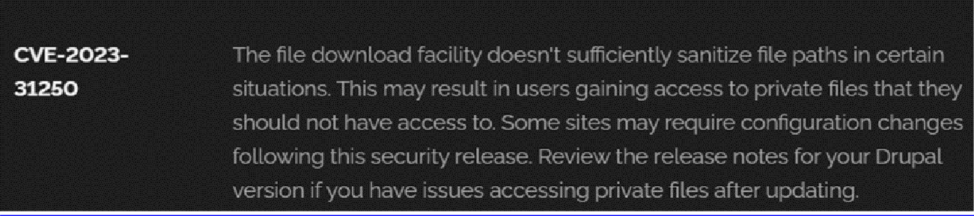

2. Vulnerability Name: - Invalid Certificate
CWE/CVE: - CWE-395
OWASP/SANS Category: - A07:2021 – Identification and Authentication Failures

Description: -
When a certificate is invalid or malicious, it might allow an attacker to spoof a trusted entity by interfering in the communication path between the host and client. The product might connect to a malicious host while believing it is a trusted host, or the product might be deceived into accepting spoofed data that appears to originate from a trusted host.

Business Impact: -
Improper certificate validation can lead to a range of security threats which includes Man-inthe-middle attacks(Attackers can intercept communication between two parties and read or modify the data exchanged between them),Data breaches:(Attackers can gain unauthorized access to sensitive information or sensitive systems, leading to data breaches),Malware distribution(Attackers can use fake digital certificates to distribute malicious software or infect systems with malware).
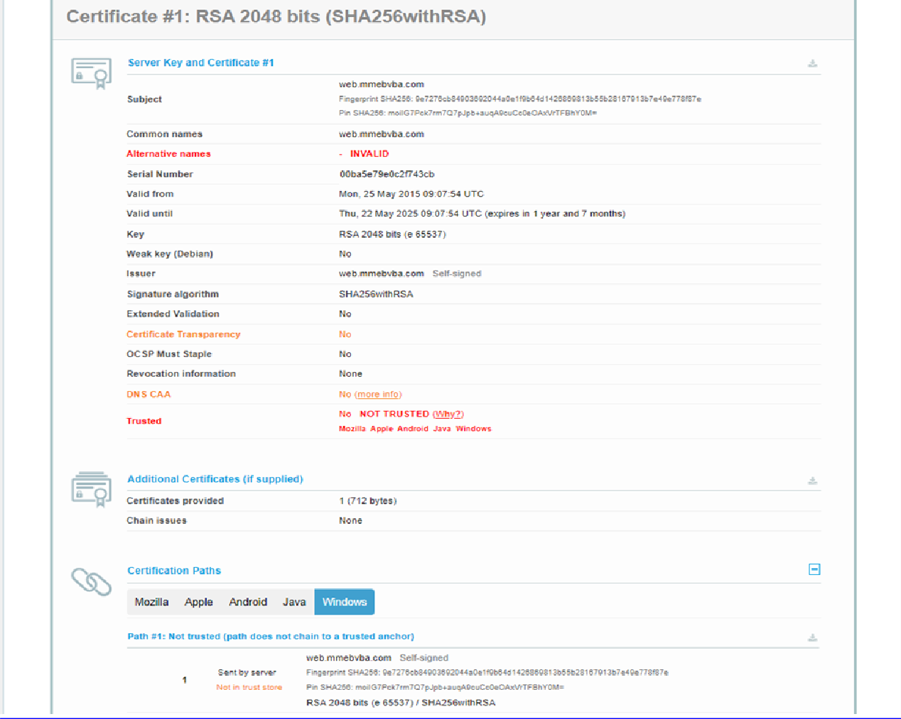

3. Vulnerability Name: - Missing X-Frame-Options Header CWE/CVE: CWE-1021
OWASP/SANS Category: - A04:2021-Insecure Design

Description: -
A web application is expected to place restrictions on whether it is allowed to be rendered within frames, iframes, objects, embed or applet elements. Without the restrictions, users can be tricked into interacting with the application when they were not intending to.

Business Impact: -
This enables path to the attackers to manipulate or gain unauthorized access to user interface elements, potentially leading to deceptive or malicious user interactions. This can result in data leakage, fraud, user distrust, and reputational damage, undermining the integrity and trustworthiness of the application and causing financial losses.
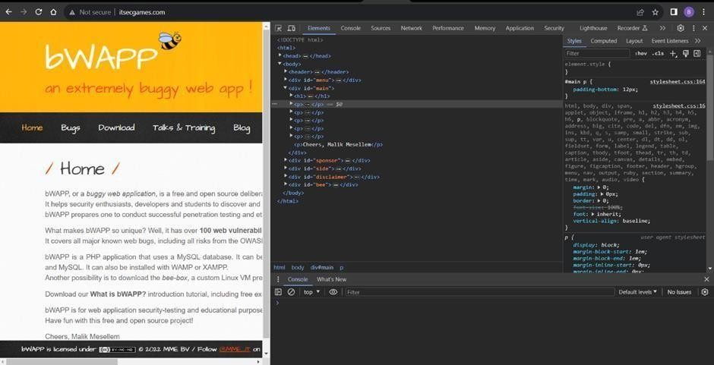

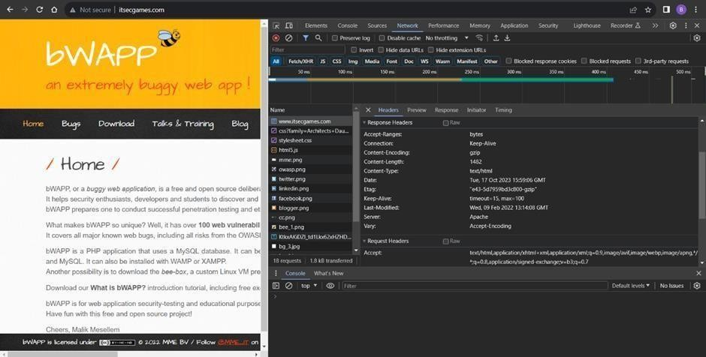

4. Vulnerability Name: - X-Content-Type Options Header Missing
CWE/CVE: 918
OWASP/SANS Category: - A10:2021 – Server-Side Request Forgery (SSRF)

Description: -
The web server receives a URL or similar request from an upstream component and retrieves the contents of this URL, but it does not sufficiently ensure that the request is being sent to the expected destination.

Business Impact: -
The header missing impact Data Exposure(Attackers might force the server to render sensitive data as HTML, leading to data exposure),Security Risks(Content type manipulation can increase security risks, potentially leading to breaches, data leaks, and unauthorizedaccess), Brand and Reputation Damage(Successful attacks that exploit SSRF vulnerabilities can harm the organization's reputation and trustworthiness)
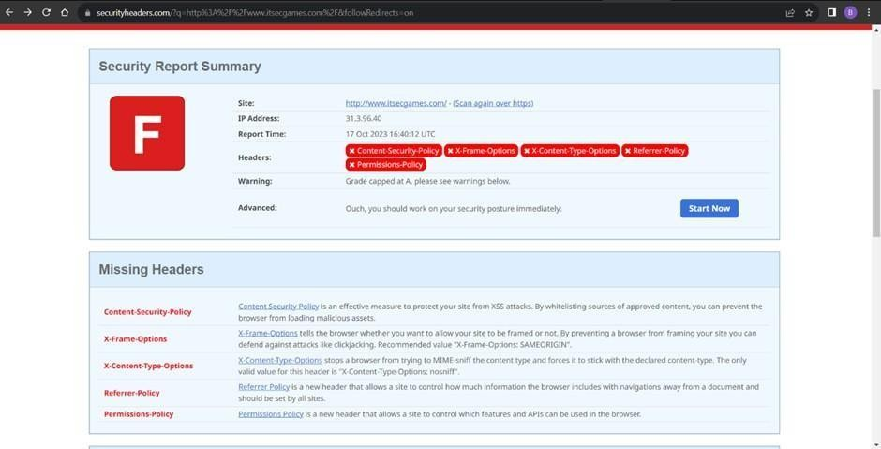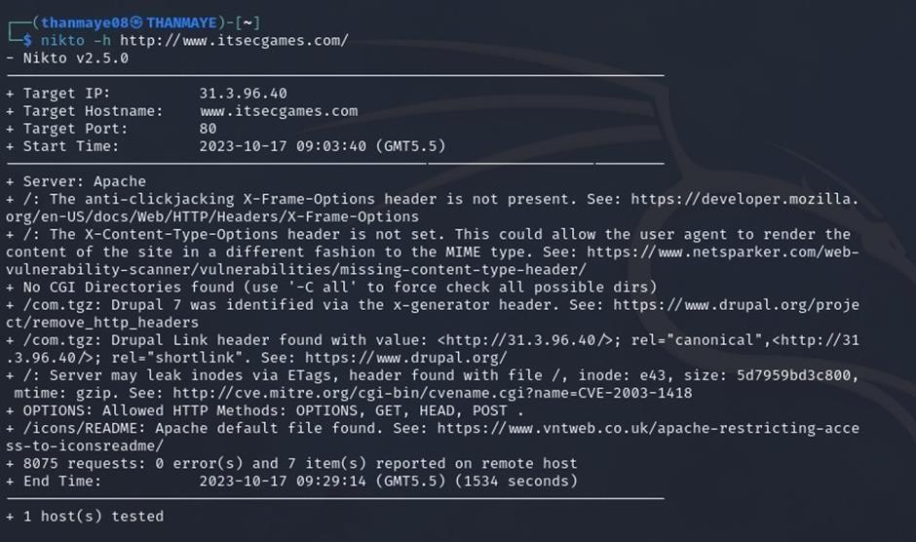
5. Vulnerability Name: - Drupal Ajax API shows JSONP not disabled by default
CWE/CVE: CWE-937
OWASP/SANS Category: - A06:2021-Vulnerable and Outdated Components

Description: -
Vulnerable and outdated components refer to using software libraries, modules, or
dependencies within a web application that have known security issues or are not updated to the latest secure versions. This can include plugins, frameworks, or APIs that are no longer maintained or have publicly documented vulnerabilities.

Business Impact: -
The presence of vulnerable and outdated components in a web application poses
significant security risks. Attackers can exploit these weaknesses to gain unauthorized access, inject malicious code, steal sensitive data, or disrupt the system's operation. The potential business impacts include compromised user data, damaged reputation, legal consequences, and financial losses due to breach recovery and remediation efforts.
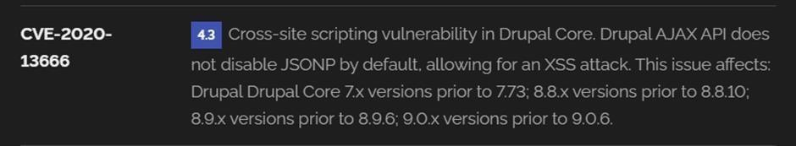

6. Vulnerability Name: - Drupal Api Vulnerability
CWE/CVE: CWE-20
OWASP/SANS Category: - A03:2021 – Injection

Description: -
The product receives input or data, but it does not validate or incorrectly validates that
the input has the properties that are required to process the data safely and correctly.

Business Impact: -
The impact of a successful SQL injection attack can be devastating for businesses. It
can result in unauthorized access to sensitive information, data theft, financial losses, damage to reputation, and legal consequences. Depending on the nature of the application and data involved,
SQL injection can lead to compliance violations, customer trust erosion, and operational disruption.
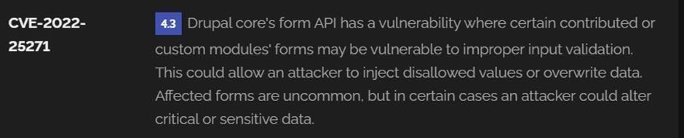

7. Vulnerability Name: - Improper API Filtration
CWE/CVE: CWE-79
OWASP/SANS Category: - A07-2017: Cross-site Scripting (XSS)

Description: -
The product does not neutralize or incorrectly neutralizes user-controllable input before it is placed in output that is used as a web page that is served to other users.

Business Impact: -
If exploited, this vulnerability allows attackers to inject malicious scripts into web pages, which can be viewed by other users. The potential business impacts include data theft, unauthorized access, compromised user accounts, damaged reputation, and financial losses. Attackers can use XSS to steal sensitive information, such as user credentials, personal data, or financial details, leading to regulatory compliance violations and legal liabilities. Additionally, defacement or manipulation of website content can erode customer trust and result in lost revenue.
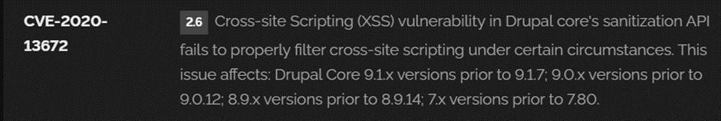

8. Vulnerability Name: - Denial of Service
CWE/CVE: CWE-400
OWASP/SANS Category: -

Description: -
The Denial of Service (DoS) attack is focused on making a resource (site, application,
server) unavailable for the purpose it was designed. There are many ways to make a service unavailable for legitimate users by manipulating network packets, programming, logical, or resources handling vulnerabilities, among others. If a service receives a very large number of requests, it may cease to be available to legitimate users. In the same way, a service may stop if a programming vulnerability is exploited, or the way the service handles resources it uses.

Business Impact: -
If successfully exploited, it involves overwhelming a system or application with
excessive demands on its resources. This can lead to a range of disruptive consequences. The targeted system may experience significant slowdowns, or even complete unresponsiveness, making it difficult or impossible for legitimate users to access. Critical resources like CPU, memory, and network bandwidth can become depleted, causing further degradation in performance. In severe cases, the exploited vulnerability may lead to system crashes or failures, potentially resulting in data loss.
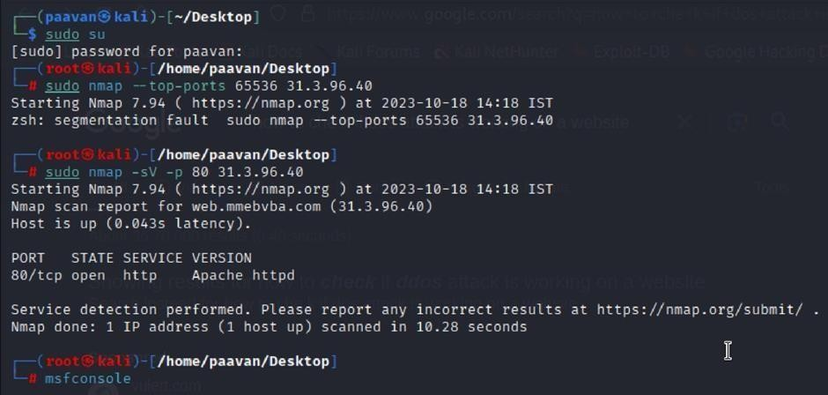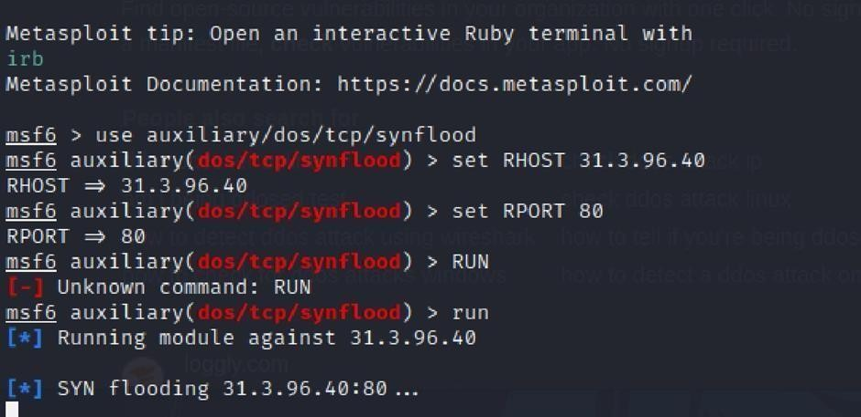

9. Vulnerability Name: - TLS Version 1.0 Protocol Detection
CWE/CVE: CWE-327
OWASP/SANS Category: - A02:2021-Cryptographic Failures
Description: -
The product uses a broken or risky cryptographic algorithm or protocol.

Business Impact: -
TLS 1.0 is an outdated and vulnerable encryption protocol, and its use can expose
sensitive data to potential security threats. This not only jeopardizes the integrity of customer information and payment details but also tarnishes the company's reputation. The business may face legal consequences, loss of customer trust, and decreased revenue as security- conscious users avoid the site due to its security vulnerabilities. Immediate action is necessary to upgrade to a more secure TLS version to safeguard data, ensure compliance, and maintain customer confidence.
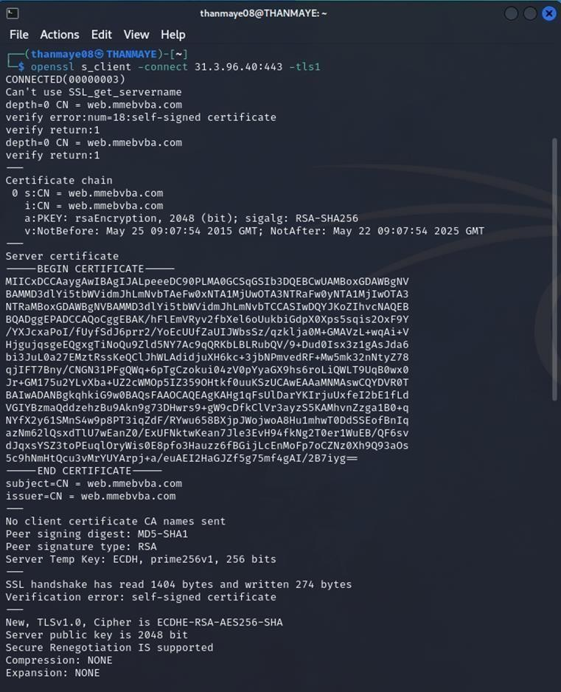
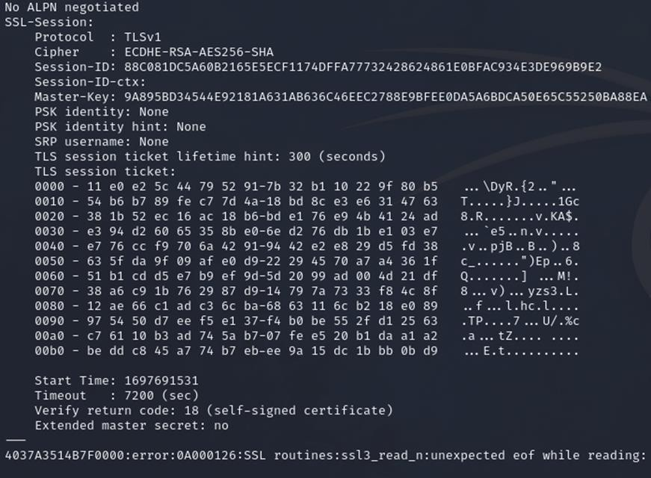

10. Vulnerability Name: - web.config File Information Disclosure
CWE/CVE: CWE-497
OWASP/SANS Category: - A3:2017-Sensitive Data Exposure

Description: -
An information disclosure vulnerability exists in the remote web server due to the disclosure of the web.config file. An unauthenticated, remote attacker can exploit this, via a simple GET request, to disclose potentially sensitive configuration information.

Business Impact: -
It exposes sensitive configuration details, including database connection strings and encryption keys, to potential attackers. This could lead to unauthorized access, data breaches, and system compromise. The impact includes financial losses, damage to reputation, and legal liabilities as the organization's security and customer trust are compromised.

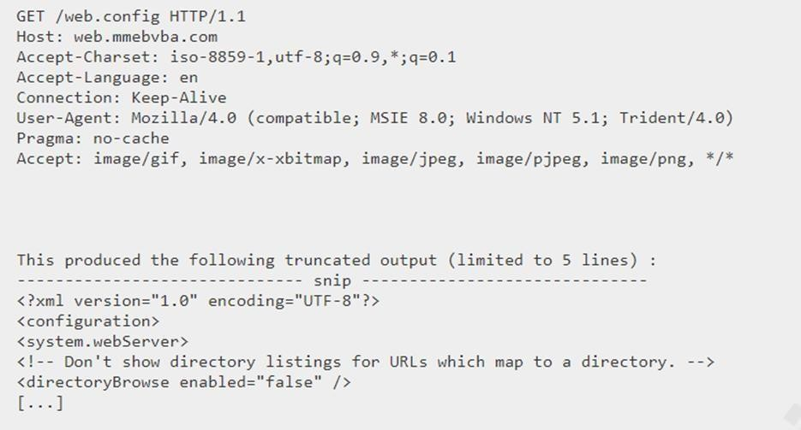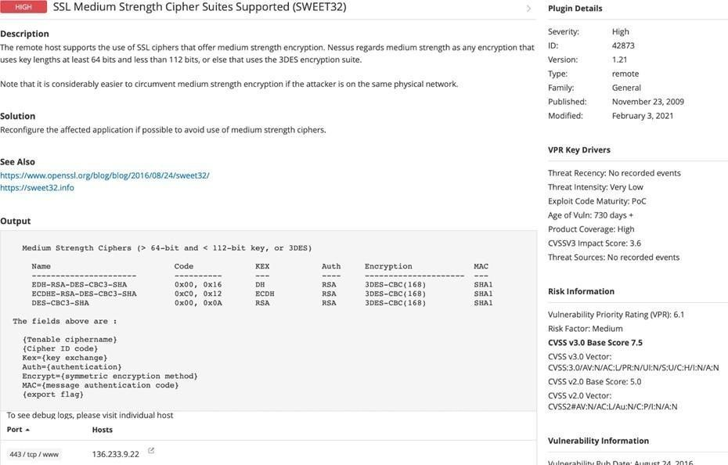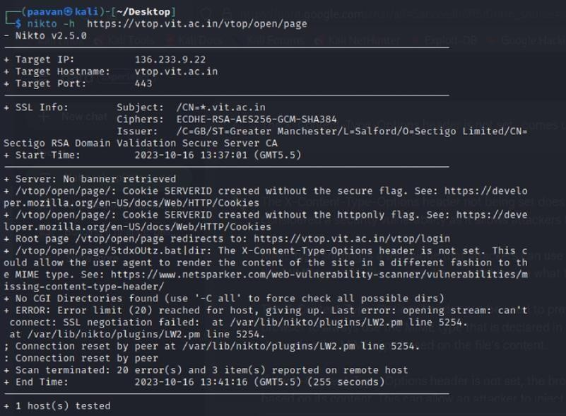

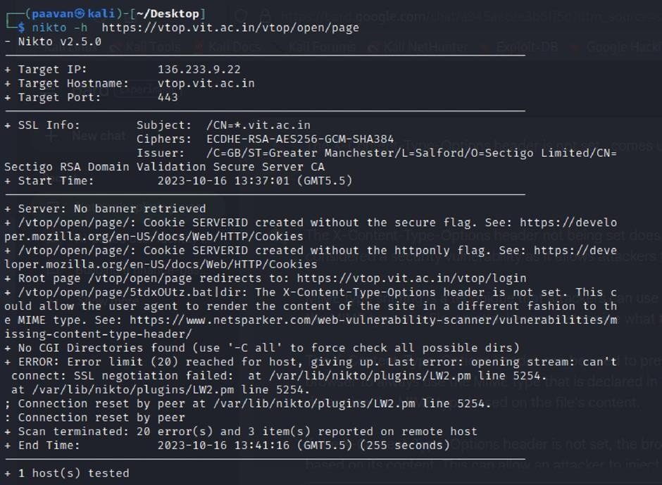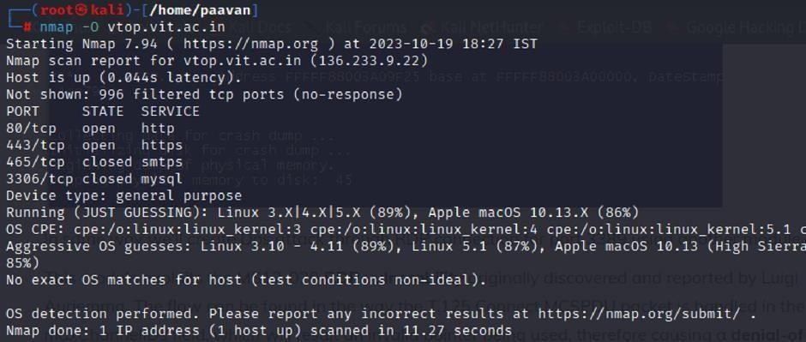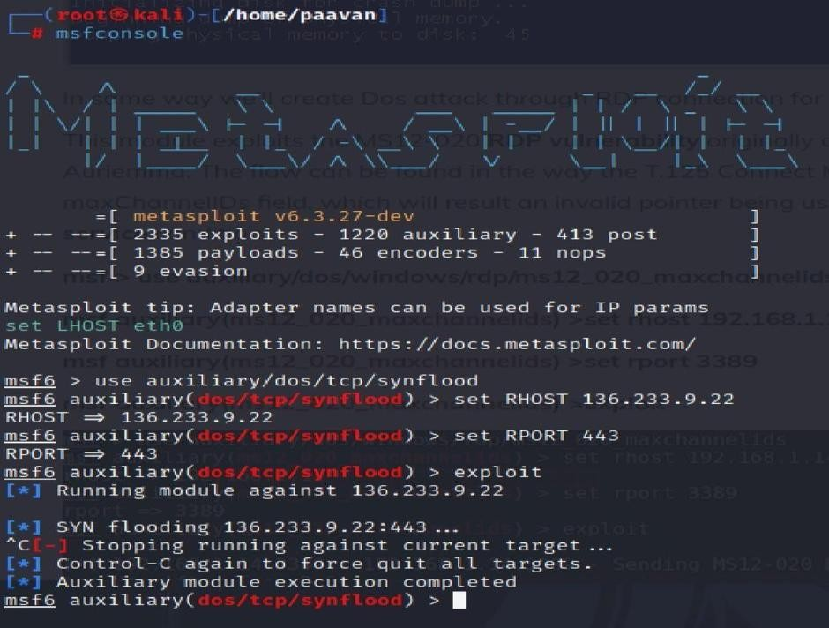

STAGE 2

OVERVIEW :-

Nessus is a vulnerability scanner developed by Tenable, Inc. It is a remote scanner, meaning
that it does not need to be installed on the target host to scan it. Nessus works by sending a variety of probes to the target host in order to identify vulnerabilities. These probes can include network traffic, operating system commands, and application requests.
When Nessus scans a host, it first uses a discovery plugin to identify the operating system and services running on the host. Once the host has been discovered, Nessus runs a series of plugins to test for vulnerabilities. For each vulnerability that Nessus finds, it provides a detailed report that includes the severity of the vulnerability, the steps to reproduce the vulnerability, and the steps to remediate the vulnerability.
Nessus can be used to scan a variety of targets, including single hosts, networks, and web
applications. It can also be used to scan specific ports and services. Nessus can be configured to run scans on a schedule or manually.

Here are some of the benefits of using Nessus:

- Comprehensive vulnerability coverage: Nessus has over 1200 plugins available, covering a wide range of vulnerabilities in operating systems, applications, and network devices.
- Easy to use: Nessus has a user-friendly interface that makes it easy to configure and run scans.
- Comprehensive reporting: Nessus provides detailed reports that include the severity of each vulnerability,the steps to reproduce the vulnerability, and the steps to remediate the vulnerability.
- Scalability: Nessus can be used to scan a variety of targets, including single hosts, networks, and web applications.
- Flexibility: Nessus can be configured to run scans on a schedule or manually.

Nessus is a powerful tool that can be used to improve the security of any network. It is a valuable asset for any security professional.

Target website :- gin&juiceshop
Target ip address:- 65.61.137.117

List of vulnerability :-
s.no |  | Vulnerability name | Severity | plugins
 | 1 | TLS Version 1.0  Protocol  Detection | MEDIUM | 104743
 | 2 | TLS Version 1.1 Protocol  Deprecated | MEDIUM | 157288
 | 3 | SSL/TLS Diffie-  Hellman Modulus  <= 1024 Bits (Logjam) | LOW | 83875
 | 4 | ICMP Timestamp  Request Remote  Date Disclosure | INFO | 10114
 | 5 | Additional DNS Hostnames | INFO | 46180
 | 6 | Apache Tomcat Detection | INFO | 39446
 | 7 | Common Platform Enumeration  (CPE) | INFO | 45590
 | 8 | Device Type | INFO | 54615
 | 9 | HSTS Missing From HTTPS Server | INFO | 84502
 | 10 | HTTP Server Type and Version | INFO | 10107

REPORT: -

1) Vulnerability Name: - 104743 - TLS Version 1.0 Protocol Detection
Severity: - MEDIUM
Plugin: - 104743
Port: - 443
Description: -
The remote service accepts connections encrypted using TLS 1.0. TLS 1.0 has a number of cryptographic design flaws. Modern implementations of TLS 1.0 mitigate these problems, but newer versions of TLS like 1.2 and 1.3 are designed against these flaws and should be used whenever possible. As of March 31, 2020, Endpoints that aren’t enabled for TLS 1.2 and higher will no longer function properly with major web browsers and major vendors. PCI DSS v3.2 requires that TLS 1.0 be disabled entirely by June 30, 2018, except for POS POI terminals (and the SSL/TLS termination points to which they connect) that can be verified as not being susceptible to any known exploits.
Solution: - Enable support for TLS 1.2 and 1.3, and disable support for TLS 1.0.
Business Impact: -
Continued use of TLS 1.0's encryption, known for its inherent cryptographic flaws, exposes the organization to heightened security risks, increasing the likelihood of data breaches and cyberattacks. This vulnerability jeopardizes compliance with industry standards, specifically PCI DSS v3.2, which mandates the complete cessation of TLS 1.0 use. Non- compliance risks regulatory penalties and erodes customer trust. Moreover, endpoints that lack support for TLS 1.2 and higher will experience impaired functionality with major web browsers and vendors, potentially leading to lost business opportunities and damage to the organization's reputation. Addressing this vulnerability is imperative to mitigate these multifaceted risks and maintain a secure and trustworthy online presence.

2) Vulnerability Name: - 157288 - TLS Version 1.1 Protocol Deprecated
Severity: - MEDIUM
Plugin: - 157288
Port: - 443
Description: -
The remote service accepts connections encrypted using TLS 1.1. TLS 1.1 lacks support for current and recommended cipher suites. Ciphers that support encryption before MAC computation, and authenticated encryption modes such as GCM cannot be used with TLS 1.1 As of March 31, 2020, Endpoints that are not enabled for TLS 1.2 and higher will no longer function properly with major web browsers and major vendors.
Solution: - Enable support for TLS 1.2 and/or 1.3, and disable support for TLS 1.1.
Business Impact: -
The continued use of TLS 1.1 with its lack of support for modern cipher suites and advanced encryption methods jeopardizes the organization's security posture, increasing vulnerability to cyber threats and potential data breaches. Additionally, endpoints not upgraded to support TLS 1.2 and higher will encounter compatibility issues with major web browsers and vendors, impacting user experience and potentially leading to missed business opportunities. Swift remediation of this vulnerability is essential to mitigate security risks and ensure seamless interactions with web browsers and vendors, preserving the organization's reputation and operational efficiency.

3) Vulnerability Name: - 83875 - SSL/TLS Diffie-Hellman Modulus <= 1024 Bits (Logjam)
Severity: - LOW
Plugin: - 83875
Port: - 443
Description: -
The remote host allows SSL/TLS connections with one or more Diffie-Hellman moduli less than or equal to 1024 bits. Through cryptanalysis, a third party may be able to find the shared secret in a short amount of time (depending on modulus size and attacker resources). This may allow an attacker to recover the plaintext or potentially violate the integrity of connections.
Solution: - Reconfigure the service to use a unique Diffie-Hellman moduli of 2048 bits or greater.
Business Impact: -
Allowing SSL/TLS connections with weak Diffie-Hellman moduli raises security concerns. An attacker with sufficient resources and computing power could compromise the shared secret relatively quickly, potentially leading to the decryption of sensitive data or the violation of connection integrity. While the severity is low, the risk of data breaches and integrity compromise should not be underestimated, and it is essential to address this vulnerability to maintain data security and user trust.

4) Vulnerability Name: - 10114 - ICMP Timestamp Request Remote Date Disclosure
Severity: - INFO
Plugin: - 10114
Port: - 0

Description: -
The remote host answers to an ICMP timestamp request. This allows an attacker to know the date that is set on the targeted machine, which may assist an unauthenticated, remote attacker in defeating time-based authentication protocols.Timestamps returned from machines running Windows Vista / 7 / 2008 / 2008 R2 are deliberately incorrect, but usually within 1000 seconds of the actual system time.
Solution: - Filter out the ICMP timestamp requests (13), and the outgoing ICMP timestamp replies
(14).
Business Impact: -
This does not pose an immediate threat to business operations or data security. This vulnerability allows external parties to request the system's date and time information remotely. While it does not present a significant risk, it could potentially be used by attackers for reconnaissance purposes. Therefore, it is advisable to address this vulnerability as part of a broader security posture to reduce the risk of unauthorized data gathering and protect against potential future threats.

5) Vulnerability Name: - 46180 - Additional DNS Hostnames
Severity: - INFO
Plugin: - 46180
Port: - 0
Description: -
Hostnames different from the current hostname have been collected by miscellaneous plugins. Nessus has generated a list of hostnames that point to the remote host.Note that these are only the alternate hostnames for hosts discovered on a web server.Different web servers may be hosted on name-based virtual hosts.
Solution: - If you want to test them, re-scan using the special vhost syntax, such as : www.example.com [192.0.32.10]
Business Impact: -
This does not pose an immediate threat to business operations or data security. It indicates the discovery of hostnames that are associated with the remote host, particularly in cases of web servers utilizing name-based virtual hosts. While not a security risk on its own, it could be useful for understanding the server's configuration and infrastructure. Organizations should consider this information as part of their network documentation but do not need to take immediate action to mitigate it as a security threat.

6) Vulnerability Name: - 39446 - Apache Tomcat Detection
Severity: - INFO
Plugin: - 39446
Port: - 80
Description: -
Nessus was able to detect a remote Apache Tomcat web server.
Solution: - n/a
Business Impact: -
Is an informational finding that identifies the presence of a remote Apache Tomcat web server. While this information itself does not indicate a security threat or impact on business operations, it can be useful for network administrators and security professionals to be aware of the technologies in use on their network. Understanding the presence of an Apache Tomcat server can be valuable for maintaining and securing web applications, but it does not require immediate action to mitigate a security risk.

7) Vulnerability Name: - 45590 - Common Platform Enumeration (CPE)
Severity: - INFO
Plugin: - 45590
Port: - 0
Description: -
By using information obtained from a Nessus scan, this plugin reports CPE (Common Platform Enumeration) matches for various hardware and software products found on a host.Note that if an official CPE is not available for the product, this plugin computes the best possible CPE based on the information available from the scan.
Solution: - n/a
Business Impact: -
This provides insights into hardware and software products identified on a host through a Nessus scan. It reports CPE matches, which are standardized identifiers for these products. This information is valuable for asset management and inventory purposes. While it doesn't signify a security threat, it aids administrators in understanding the components within their network, contributing to effective resource management and facilitating future system maintenance.

8) Vulnerability Name: - Device Type
Severity: - INFO
Plugin: - 54615
Port: - 0
Description: -
Based on the remote operating system, it is possible to determine what the remote system type is (eg: a printer, router, general-purpose computer, etc).
Solution: -
Business Impact: -
It allows for the identification of the remote system type, such as a printer, router, or generalpurpose computer, based on the remote operating system. While this doesn't pose a direct security threat, it offers valuable insights for network administrators to better understand and classify the devices in their network. This information aids in network management, optimization, and ensures that the right security measures are in place for each device type.

9) Vulnerability Name: - 84502 - HSTS Missing From HTTPS Server
Severity: - INFO
Plugin: - 84502
Port: - 443
Description: -
The remote HTTPS server is not enforcing HTTP Strict Transport Security (HSTS). HSTS is an optional response header that can be configured on the server to instruct the browser to only communicate via HTTPS. The lack of HSTS allows downgrade attacks, SSL- stripping man-in-themiddle attacks, and weakens cookie-hijacking protections.
Solution: - Configure the remote web server to use HSTS.
Business Impact: -
Indicates that the remote HTTPS server does not enforce HTTP Strict Transport Security (HSTS). HSTS is a crucial security feature that, when configured on the server, instructs web browsers to communicate exclusively via HTTPS, enhancing security. The absence of HSTS potentially exposes the server to downgrade attacks, SSL-stripping man-in-the- middle attacks, and weakens protections against cookie hijacking, posing risks to data confidentiality and user security. Enabling HSTS is essential to ensure a higher level of protection for data transmitted between clients and the server.

10) Vulnerability Name: - 10107 - HTTP Server Type and Version
Severity: - INFO
Plugin: - 10107
Port: - 443
Description: -
This plugin attempts to determine the type and the version of the remote web server.
Solution: - N/A
Business Impact: -
This relates to the identification of the remote web server's type and version. While this issue doesn't pose an immediate security threat, it can provide valuable information to potential attackers about the server's software stack. Knowledge of the server type and version may aid attackers in exploiting known vulnerabilities specific to that software, making it important to restrict such information from being easily accessible to enhance the server's overall security posture.

STAGE – 3

REPORT

Title of the Project: -
Implement and manage Zero Trust Network Access (ZTNA) using Zscaler by enabling secure, identity-based user-to-application connectivity without exposing internal networks

- Centralized Identity Management
Centralized Identity Management is a key component in implementing Zero Trust Network Access (ZTNA) using Zscaler. In traditional network security models, access decisions are often based on the user’s network location, such as whether they are inside or outside the corporate network. However, in a Zero Trust model, access decisions are based primarily on verified user identity. Zscaler integrates with enterprise identity providers such as Active Directory, Azure Active Directory, Okta, and other Identity and Access Management (IAM) systems to create a centralized identity management framework.
Through centralized identity management, organizations can maintain a single source of truth for user identities, roles, and permissions. All user authentication and authorization processes are handled through the centralized identity system, ensuring consistency across different applications and services. This simplifies administrative tasks, as IT teams no longer need to manage multiple user accounts or access policies across different systems. Instead, identity information is synchronized and managed in one location.
Another major benefit is improved security. Since ZTNA relies on identity-based access rather than network access, every request to access an application is verified based on the user’s identity, device posture, and security policies. This ensures that only authenticated and authorized users can access specific resources. Centralized identity management also allows organizations to quickly update access privileges when employees change roles or leave the organization. By implementing centralized identity management within Zscaler ZTNA, organizations can achieve stronger security, simplified administration, and more efficient access control.

- Single Sign-On (SSO) Authentication
Single Sign-On (SSO) authentication plays an important role in improving both security and user experience in a ZTNA environment. SSO allows users to authenticate once and gain access to multiple applications without repeatedly entering their credentials. When integrated with Zscaler ZTNA, SSO provides a seamless and secure method for accessing enterprise applications while maintaining strong authentication controls.
In a traditional environment, users often have to remember and manage multiple usernames and passwords for different applications. This can lead to password fatigue, where users reuse weak passwords or write them down, increasing security risks. SSO eliminates this problem by allowing users to log in once through a trusted identity provider and gain access to authorized applications. Once authenticated, Zscaler verifies the user’s identity and grants access according to predefined security policies.
From a security perspective, SSO reduces the number of authentication points and centralizes authentication processes. Administrators can enforce strong authentication policies through the identity provider, such as password complexity rules or multi-factor authentication. If a user’s account needs to be disabled or modified, administrators can update the identity provider, and the changes automatically apply to all connected applications. This simplifies identity management while maintaining high security standards.
Overall, SSO improves productivity by allowing users to quickly access the resources they need while ensuring that access remains secure and centrally controlled.

3. Enhanced Security and Access Control
One of the primary objectives of implementing ZTNA using Zscaler is to enhance security and strengthen access control mechanisms. Traditional network security approaches typically grant users access to an entire internal network once they successfully authenticate through a VPN. This model increases the risk of lateral movement within the network if an attacker compromises a user account. ZTNA eliminates this risk by providing application-level access rather than network-level access.
With Zscaler ZTNA, users are granted access only to specific applications they are authorized to use. This approach follows the principle of least privilege, which ensures that users receive only the minimum level of access necessary to perform their tasks. Access decisions are based on multiple factors, including user identity, device health, location, and security policies defined by administrators.
Additionally, Zscaler continuously evaluates access requests in real time. If any suspicious activity or security risk is detected, the system can automatically block or restrict access. This dynamic access control mechanism significantly reduces the attack surface and prevents unauthorized access to sensitive resources.
By restricting access to individual applications and continuously verifying security conditions, organizations can protect critical systems from cyber threats such as credential theft, insider attacks, and unauthorized access. This approach provides a stronger and more flexible security framework compared to traditional network security models.

4. Automated User Provisioning and Deprovisioning
Automated user provisioning and deprovisioning are essential features for efficiently managing user access in modern organizations. In a ZTNA environment implemented with Zscaler, automation ensures that users receive the appropriate level of access based on their roles within the organization. This process is typically integrated with identity management systems and directory services.
User provisioning refers to the process of granting access to applications and resources when a new employee joins the organization or when an existing employee requires additional access. Instead of manually configuring access for each user, administrators can define role-based policies that automatically assign permissions based on job roles or departments. This reduces administrative workload and ensures consistent access control policies across the organization.
Deprovisioning is equally important for maintaining security. When an employee leaves the organization or changes roles, their access to certain applications must be immediately revoked or modified. Automated deprovisioning ensures that these changes occur instantly through the identity management system. This prevents former employees or unauthorized users from retaining access to sensitive systems and data.
Automation also reduces the risk of human error, which is a common cause of security vulnerabilities in manual access management processes. By implementing automated provisioning and deprovisioning within Zscaler ZTNA, organizations can maintain accurate access controls while improving operational efficiency and security.

5. Multi-Factor Authentication (MFA) Support
Multi-Factor Authentication (MFA) is a critical security feature that strengthens the authentication process by requiring users to provide multiple forms of verification. In addition to entering a password, users must confirm their identity using an additional factor such as a mobile authentication app, a one-time password, biometric verification, or a hardware security token.
When Zscaler ZTNA is integrated with identity providers that support MFA, organizations can significantly enhance their security posture. Even if an attacker obtains a user’s password through phishing or other attacks, they would still need the additional authentication factor to gain access. This greatly reduces the likelihood of unauthorized access to enterprise applications.
MFA is particularly important in modern work environments where employees access corporate applications from various locations and devices. By requiring multiple forms of authentication, organizations can ensure that only legitimate users can access sensitive resources. Administrators can also configure MFA policies based on risk factors, such as requiring additional verification when users attempt to access applications from unfamiliar devices or locations.
Overall, MFA adds an essential layer of security to ZTNA deployments and helps organizations protect their systems from credential-based attacks.

6. Improved Monitoring, Logging, and Compliance
Effective monitoring and logging are essential for maintaining visibility into user activities and ensuring that security policies are being properly enforced. Zscaler ZTNA provides detailed monitoring and logging capabilities that allow administrators to track user access to applications in real time. These logs include information such as user identity, device details, access location, and the specific applications accessed.
This visibility enables security teams to detect suspicious behavior and respond quickly to potential security threats. For example, if a user attempts to access an application from an unusual location or device, administrators can investigate the activity and take appropriate action. Continuous monitoring also helps organizations identify potential vulnerabilities and improve their overall security posture.
In addition to improving security, logging and monitoring support regulatory compliance requirements. Many organizations must comply with industry regulations and standards that require detailed records of user access and security events. Zscaler’s reporting and logging capabilities provide the necessary documentation to demonstrate compliance with these requirements.
By providing comprehensive monitoring, logging, and reporting features, Zscaler ZTNA helps organizations maintain strong security governance, quickly detect threats, and ensure compliance with regulatory standards.

